At Stebbing Green Day nursery, we believe that nutritious food and drink are essential for children’s wellbeing. When planning our menus we have regard to the Eat well guide (https://www.nhs.uk/live-well/eat-well/food-guidelines-and-food-labels/the-eatwell-guide/) to ensure the children get the right amount of the 4 food groups – fruit/ vegetables/ starch/ dairy and protein.
We will ensure that all meals and snacks are nutritious, healthy and balanced. Children’s medical and personal dietary requirements are always known and respected (Parents/carers are required to provide details when their child is enrolled into the nursery). Multicultural diet is always offered, to make sure those children from all backgrounds encounter familiar tastes and that all children have the opportunity also to try new food. Dietary rules of religious groups, vegetarians/vegans are known and met in an appropriate way, making sure that they are always respected and valued within the setting. All food served to children with allergies is served using the plates and bowls that are colour coded using the key which is up on the wall in each kitchen.
Unfortunately, Stebbing Green Day Nursery cannot accommodate requests for any food preferences where there is no medical/cultural or religious need. Requests for dietary requirements will need to be accompanied by a medical note.

Food Safety
Stebbing Green Day Nursery is committed to ensuring that safe and healthy practices around the storage, preparation and the service of food are maintained throughout the setting. We pride ourselves on 5* Environmental Health Rating from the LA.
The setting has set high standards of personal hygiene for all members of staff involved in the handling and preparation of food. Any person preparing or serving food will have their hair tied back, wear a white apron and thoroughly washed their hands. In addition, gloves may be worn if staff would like. Any person showing signs of ill health will not be permitted to handle food.
Only staff who have successfully completed a food hygiene and allergy awareness course will be allowed to prepare and serve snacks and meals.
We make use of the “Safer Foods, Better Business” pack and guidance published by the Food Standards Agency (FSA). This is kept up to date and checked regularly at supervisions. We are also annually inspected by Environmental health to ensure health and hygiene standards are being met. All evidence and records of our excellent practice is available to view at any time.
When preparing food, staff (kitchen or general) will observe current legislation regarding food hygiene and training by:
- Always washing hands with anti-bacterial soap and hot water before and after handling food, using the toilet or changing nappies.
- Using clean, disposable cloths
- Ensuring the use of the correct colour coded chopping boards (e.g. red for raw meat etc.)
- Ensuring that red utensils and crockery are used to prepare all food that is allergen free
- Not being involved in food preparation if they are unwell
- Wearing correct sterile clothing- white apron, or one designated for kitchen use, closed toe shoes, hair tied back etc.
- Holding a current Food Hygiene certificate level 2.
- Making sure all fruit and vegetables are washed before being served.
- Avoid wearing jewellery, especially rings, watches and bracelets.
- Any cuts, spots or sores on the hands and arms must be covered completely with a waterproof dressing
- Fingernails should be kept short and clean, food handlers, including children should not wear nail varnish as this may contaminate food.
- Ensuring all preparation areas and equipment are kept clean and free from contamination of allergens or bacteria. Foods containing allergens are prepared separately and away from food/meals being prepared for children with allergies.

Temperature control
It is the policy of Stebbing Green Day Nursery to ensure that all foods are stored according to safe food handling practices and at the correct temperature in order to prevent the growth and multiplication of food poisoning organisms, to reduce the rate of food spoilage and to ensure that food quality is maintained.
Fridge temperatures are checked and recorded daily to ensure the correct temperature is being upheld.

Cleaning of Food Preparation Areas
Stringent cleaning routines of the kitchen each day are carried out. Further deeper cleans of equipment, cupboards, areas of the kitchen etc are scheduled for weekly and monthly tasks.
- A record is maintained of these cleaning routines.
- Every week the fridge is thoroughly cleaned and all items in the fridge are checked for freshness, and all food past their use by or best before date are correctly disposed of.
- Shelves and drawers are removed and cleaned with warm soapy water
- The inside walls are cleaned from top to bottom with anti-bacterial cleaner
- The seals around the fridge are cleaned to ensure no spillages or stains
- Freezers are defrosted (on non-frost-free) and cleaned once a month following the same procedure.
- All food is labelled correctly and dated when opened to ensure food is safe to eat.
- All food preparation surfaces are wiped clean after use with an approved anti-bacterial cleaner and disposable cloths/paper towel.
- All chopping boards are cleaned after use with warm soapy water, anti-bacterial cleaner and then thoroughly rinsed.
- All utensils, crockery, serving dishes, plates etc used for preparing, serving or eating from, that are used for allergen free meals, will be washed in the dishwasher or separately from the other utensils using anti-bacterial washing up liquid, to reduce the risk of cross contamination.
The manager and kitchen assistant will ensure that appropriate controls are in place to prevent cross contamination and that these controls are documented accordingly.

During meal and snack times, we will always encourage children to gain an understanding of how food and water is an essential part of growing big and strong. Our aim is to meet the dietary and religious requirements to promote children’s healthy growth and development.
We use the following guidelines from the DFE help for early years to help understand portion sizes – https://www.gov.uk/government/publications/school-food-standards-resources-for-schools/portion-sizes-and-food-groups
Choking and Safe food preparation:
Children can choke on small objects, including food. Choking often happens silently, so it is important that young children are always kept within sight and hearing of adults whilst they are eating. There will always be paediatric first aid trained staff present at the nursery throughout all rooms and cohorts. Staff complete 12hr thorough paediatric first aid training certificates which are updated every 3 years, to ensure they can respond to any emergency. Children are encouraged to sit upright in an age-appropriate chair to eat.
These foods pose a significant choking hazard and will never be offered to children at nursery:
- Lollipops or boiled sweets
- Popcorn
- Mini eggs
- Nuts
- Raw Jelly cubes
It is also important to understand the appropriate ages and stages of development and not offer certain foods to children who are not ready for them. We have a separate weening policy for babies, and children under 1yr will not be offered Honey or cow’s milk. We do not offer pasteurised or mould ripened cheeses due to the risk of harmful bacteria, or rice milk drinks due to high levels of arsenic present.
WE ARE A NUT FREE SETTING.
As well as close supervision, it is important that foods are prepared carefully and correctly before being offered to children to ensure they do not pose a choking risk. This is how our snack foods are prepared:

Food | Safe preparation | Information
Cheddar cheese | Grated or cut into short strips | Cut lumps as narrow as possible
carrot | Grated or cut into narrow battens. | For younger babies, carrots should be cooked to soften or mashed.
Sausage | Peel off the skin, before cutting in half lengthways and then into thin strips. | NO CIRCLE SLICES
Chery tomatoes | Cut into quarters
Grapes and blueberries | Cut into quarters
Banana | Cut into thirds and then in half lengthways before cutting into strips. | NO CIRCLE SLICES
Melon | Thin slices with skin removed
Apple | Always peel and remove pips before cutting into thin, narrow slices. | For younger babies, apples should be cooked to soften or pureed.
Canned fruit | Cut into thin slices

Food allergies
Health is promoted through identifying allergies, preventing contact with the allergenic substance and through preventing cross infection of viruses and bacterial infections. These procedures are written in line with current guidance Early Years Foundation Stage – (EYFS). The nursery manager is responsible for ensuring all staff understand and follow these procedures. Stebbing Green Day Nursery has its own Managing Food allergies and allergic reaction policy.
Stebbing Green Day Nursery will provide for children’s specific dietary needs that may include allergies or food intolerances, or religious, cultural or ethical reasons. Please read the ‘managing food allergies and allergic reactions policy’ in conjunction with this policy.
Staff are made aware of children’s specialist requirements through Health Care Plans, room inductions and procedures displayed in the room.
To help us manage the risks associated with food allergies or intolerance the setting has the following in place.
• Registration forms completed from parents prior to their children starting, which is then transferred to the database ‘Famly’.
• A detailed Health Care Plan or ‘specials form’ are then completed as appropriate by parents with the manager or key person. Any amendments requested by parents, medical professionals or incidents are reported to the manager and recorded on Famly. The Key person, room staff and nursery cook will be made aware and appropriate changes to the health care plan are made, dated and signed.
• New staff members will be asked to read the ‘specials folder’ as part of their induction, which includes information on children’s allergies, medical needs and dietary requirements. Staff read and sign the specials folder monthly, which is monitored by a senior member of staff. Room leaders and Seniors will inform any new staff of the presence of children with allergies/medical needs.
•Copies of allergy information contained in the ‘specials folder’ are uploaded by the key person or parent on children’s famly profiles in the ‘notes’ section. This contains information about the condition and what to do in case of a reaction.
•Children’s allergies and medical conditions are published on the daily registers, and kept in the room with the child, so staff can be aware of the presence of any children with specific dietary needs.
•Only qualified staff are permitted to serve food to a child with food allergies AFTER checking suitability of the meal with senior staff, room leader or child’s key person.
•Practitioners undertaking kitchen duties and food preparation have access to children’s up-to-date attendance and dietary information on Famly.
•Food allergen risk assessment in place.
•Colour coded plates are used to serve food that is appropriate for children with allergies. This information is displayed in kitchen serving areas and includes a picture of the child’s face.
•Excellent food hygiene practices (5* rating)
The manager and senior staff will ensure that appropriate controls are in place to prevent cross contamination and that these controls are documented accordingly.
Dietary Requirements and food preferences (non - allergy)
When a child is registered with us at Stebbing Green Day Nursery, and the parent/carer notifies us of specific dietary needs, preferences or allergies, this information must be recorded on their registration forms on the child’s Famly profile. A health care plan will be issued for parents to complete for any allergies (see Managing Allergies and allergic reactions Policy). All dietary preferences such as (vegetarian, vegan, no pork, no beef) will be respected and alternative meals will be provided.
When providing this information please ensure the following information is provided:
•Dietary need or food preference and the reason for it (if an allergy or food intolerance, then a Health Care Plan must be completed see Managing Allergies and allergic reactions Policy)
•Any changes to the requirements must be given in writing by the parent and kept on file. The child’s Famly profile must be updated with current information by the parent/carer.
The management will:
•Ensure that the child has a placemat made up for them that states their dietary preference, to remind staff when they are serving meals.
•Provide Colour coded tableware and as part of a colour coding system, to ensure that there is no confusion between the preparation of food in the kitchen and the staff serving the meal to children with food allergies/preferences.
•We have a no nut policy throughout our nursery rooms. Parents and staff are reminded not to bring Nuts into Nursery.
•Requests for Dietary requirements where there is an allergy or food intolerance will need to be accompanied by a medical note from the doctor.
Infant feeding
Stebbing Green Day Nursery has its own Infant Feeding Policy, and the purpose of the policy is to explain our infant feeding procedures to parents and carers and to ensure consistency amongst staff who work within Stebbing Green Day Nursery when providing support and education for families around infant feeding and very early years development.
All staff employed by Stebbing Green Day Nursery work to ensure that this policy is implemented within the units and in their everyday practice
Portion control
When serving food to children, we will cut food to children’s size/ age and stage of weaning. We monitor children’s appetite and adjust portion sizes to make sure they get enough energy and nutrients. We start meals with small servings (they can have more if they are still hungry).
Stebbing Green Day Nursery packed lunch guidance/ policy
Stebbing Green Day nursery will provide facilities for children bringing in packed lunches and will ensure that fresh drinking water is always readily available. Parents are urged to be responsible in ensuring that packed lunches are as healthy as possible. All foods brought from home should be checked for potential allergens so that the risk of cross contamination is reduced. The Nursery has allocated fridge space to store packed lunches. However, parents/ carers must ensure that they are clearly labelled and. Packed lunches must NOT include:
•No nuts of any kind (including peanut butter and Nutella) because of the life-threatening risk to other children who may have a severe food allergy.
•No popcorn, marshmallows or mini eggs due to choking risk
•No confectionary such as chocolate bars and sweets (fruit strings are considered as sweets). Cereal bars are allowed but cake/biscuits are to be minimal and only as part of a balanced meal.
Packed lunches should include:
• At least one portion of fruit and one portion of vegetables.
• Meat, fish, or other source of non-dairy protein (e.g., lentils, kidney beans, chickpeas, hummus, and falafel).
•A starchy food such as any type of bread, pasta, rice, cous cous, noodles, potatoes, or other type of cereals.
•Dairy such as milk, cheese, yoghurt, fromage frais.
•Only water, fruit juice, milk, yoghurt or milk drinks and smoothies.
It is important that foods are prepared carefully and correctly before being offered to children to ensure they do not pose a choking risk.
•Small fruits such as grapes, blueberries and cherry tomatoes must be cut into quarters.
•Uncooked vegetables such as cucumber and raw carrot must be cut into thin batons or grated.
•Hard cheese must be grated or cut into short narrow strips.
•Larger fruit such as melon or apple should be cut into thin slices with skin removed.
If your child has additional educational and/or health needs, or cultural or religious beliefs which restrict their diet, please speak with staff at the nursery prior to their first day
This policy was adopted by: Stebbing Green Day Nursery | Date: 17.07.2025
To be reviewed: July 2026 | Signed: Terri Barnett and Tracey Gypps
Written in accordance with the Statutory Framework for the Early Years Foundation Stage (2025): Safeguarding and Welfare Requirements: Food and drink [3.62) safer eating (3.63-3.70] food and drink facilities (3.71).

Related policies:
- ‘Managing food allergies and allergic reactions policy’, dietary and food preferences (non- allergy).
- Infant feeding policy
Related links:
https://www.food.gov.uk/sites/default/files/media/document/Early%20Years%20Choking%20Hazards%20Table_English.pdf
- (https://www.nhs.uk/live-well/eat-well/food-guidelines-and-food-labels/the-eatwell-guide/
- https://www.gov.uk/government/publications/school-food-standards-resources-for-schools/portion-sizes-and-food-groups
- https://www.food.gov.uk/business-guidance/safer-food-better-business-sfbb
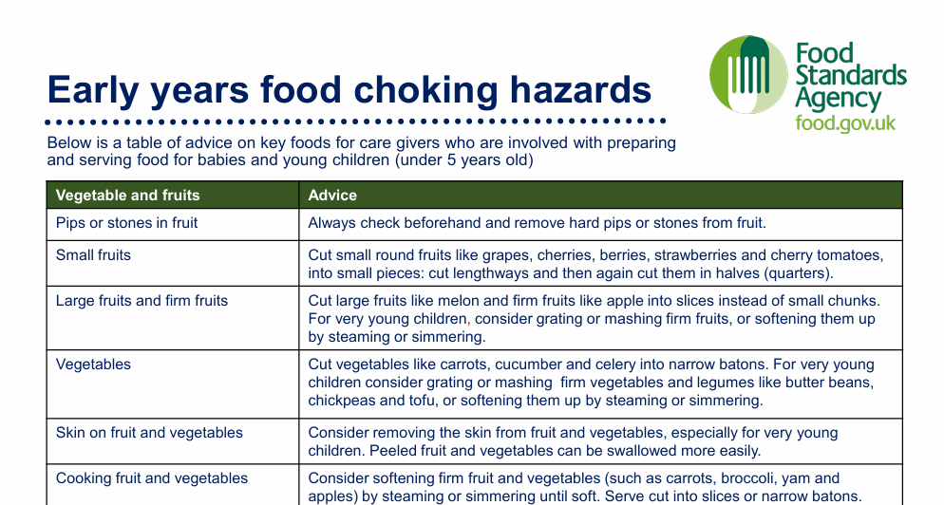
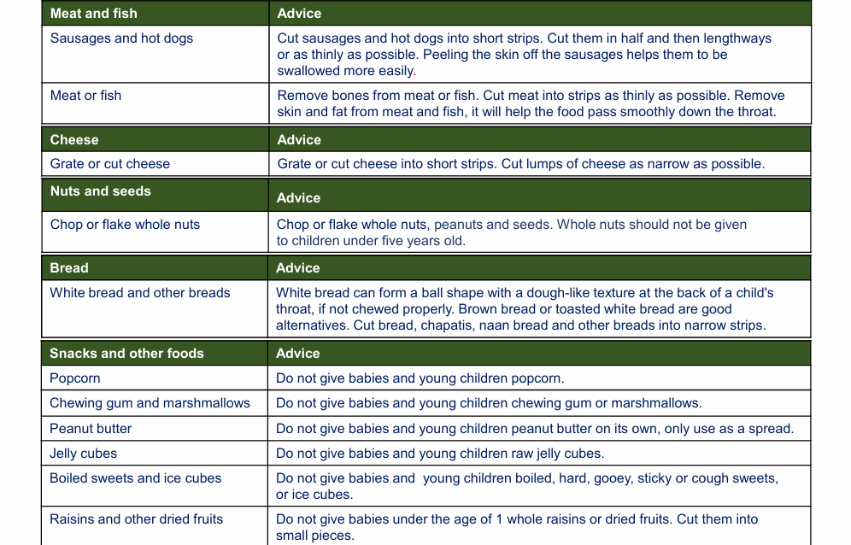

Name | Date | Signature

